CS121
Introduction to Artificial Intelligence
Winter 2004

Homework #2
(Search Problems)

Out: 1/21/03 — Due: 1/28/03

How to complete this HW: First copy this file; then insert your answers in the file immediately below each question; finally email the completed file to cs121-win0304-staff@lists.stanford.edu before 1/28 at midnight.
When you e-mail your homework, your subject line should be your leland username and then the homework you are submitting (e.g. "mykel: hw1"). If you must resubmit, make this clear in the subject line (e.g. "mykel: hw1 RESUBMIT").

Note on Honor Code: You must NOT look at previously published solutions of any of these problems in preparing your answers. You may discuss these problems with other students in the class (in fact, you are encouraged to do so) and/or look into other documents (books, web sites), with the exception of published solutions, without taking any written or electronic notes. If you have discussed any of the problems with other students, indicate their name(s) here:
………………………………………………………………………………………………
Any intentional transgression of these rules will be considered an honor code violation.

General information: In the following, whenever an explanation is required (“Why?”), there will not be full-credit without an explanation. Keep explanations short and to the point. Excessive verbosity will be penalized. If you have any doubt on how to interpret a question, either tell us in advance, so that we can help you understand the question, or tell us how you understand it in your returned solution.

Grading:

Problem# | Max. grade | Your grade
I | 5
II | 5
III | 5
IV | 5
V | 5
VI | 5
Total | 10

I. (5 points) Consider a finite search tree of uniform branching factor 6, in which all leaves lie at depth 10. There is a single goal node at depth 7. Recall that depth of the root (start node) is 0, the depth of its immediate successors is 1, etc…

In the worst-case, how many nodes are generated by:
1. Breadth-first search.
2. Depth-first search with not cutoff.
3. Depth-first search with cutoff 8.
4. Iterative-deepening search.
In each case, give the solution for the two search algorithms presented in class: in one, the goal test is applied to a node when this node is generated; in the second algorithm, the goal test is applied when the node is removed from the fringe. Explain very briefly each answer.

Let branching factor b=6, depth d=7, max depth m=10, cutoff k=8

goal test is applied to a node when this node is generated

- Breadth-first search.
1+b+b²….b^{d} = (b^{d+1}-1)/(b-1) = (6⁷⁺¹-1)/(6-1) = 335923

- Depth-first search with no cutoff.

The algorithm will generate the root, then b nodes, then (b-1) trees of depth (m-1) rooted at the first b-1 nodes, then the b successors of the last node at depth 1, then (b-1) trees of depth (m-2), etc…
So, let S(b,m) be the number of nodes (including the root) in a tree of uniform depth m and branching factor b. The number of nodes generated is:
1 [the root] + (b-1) S(b,m-1) + 1 [the last node at depth 1]
+ (b-1)S(b,m-2)+1 [the last node at depth 2]
+ (b-1)S(b,m-3) + 1
+ …
+ (b-1)S(b,m-6) + 1
+ b
= 1 + 5(S(6,9)+1+S(6,8)+1…+S(6,4)+1)+6
= 13 + 5((6¹⁰-1)/5 + (6⁹-1)/5+ (6⁸-1)/5+ (6⁷-1)/5+ (6⁶-1)/5+ (6⁵-1)/5)
= 13 + (6¹⁰+6⁹+6⁸+6⁷+6⁶+ 6⁵-6)
=7 + (60466176 + 10077696 + 1679616+ 279936+ 46656 + 7776 -6)
=72557863
where S(b,m) = (b^{m+1}-1)/(b-1)

- Depth-first search with cutoff 8.
The computation is the same as above with m=8 because of the cutoff
The number of nodes generated is:
1 [the root] + (b-1) S(b,m-1) + 1 [the last node at depth 1]
+ (b-1)S(b,m-2)+1 [the last node at depth 2]
+ (b-1)S(b,m-3) + 1
+ …
+ (b-1)S(b,m-6) + 1
+ b
= 1+ 5(S(6,7)+1+S(6,6)+1+…+S(6,2)+1) +6
= 13 + 5((6⁸-1)/5+ (6⁷-1)/5+ (6⁶-1)/5+ (6⁵-1)/5+ (6⁴-1)/5+ (6³-1)/5)
= 13 + (6⁸+6⁷+6⁶+ 6⁵+6⁴+ 6³-6)
=13 + (1679616+ 279936+ 46656 + 7776+1296+216-6)
=2015503

- Iterative-deepening search.

(d+1)1+db+(d-1) b²+…+(1) b^{d} = 8*1+7*6+6*36+5*216+4*1296+3*7776+2*46656+279936=
8+42+216+1080+5184+23328+93312+279936=
403106

(formulae were explained in lecture notes)

The interesting result is that ID produces about 1.2 more nodes that BF, while DF with no cutoff or cutoff=8 produces many more

goal test is applied when the node is removed from the fringe
- Breadth-first search: will expand all nodes one level below the shallowest goal (unless the goal is at the lowest level), except for the successors of the goal itself
1+b+b²….b^{d+1}-b=(b^{d+2}-1)/(b-1)-b=2015533
- Depth-first search with not cutoff:

1 [the root] + (b-1) S(b,m-1) + 1 [the last node at depth 1]
+ (b-1)S(b,m-2)+1 [the last node at depth 2]
+ (b-1)S(b,m-3) + 1
+ …
+ (b-1)S(b,m-6) + 1
+ (b-1)S(b,m-7) + 1
[Note:The algorithm will check the last node only when it removes it from the queue.]
= 1 + 5(S(6,9)+1+S(6,8)+1…+S(6,3)+1)
=8 + 5((6¹⁰-1)/5 + (6⁹-1)/5+ (6⁸-1)/5+ (6⁷-1)/5+ (6⁶-1)/5+ (6⁵-1)/5+ (6⁴-1)/5)
= 8 + (6¹⁰+6⁹+6⁸+6⁷+6⁶+ 6⁵+ 6⁴-7)
=8 + (60466176 + 10077696 + 1679616+ 279936+ 46656 + 7776+1296 -7)
=72559153

- Depth-first search with cutoff 8: Same as above with m=8
1 [the root] + (b-1) S(b,m-1) + 1 [the last node at depth 1]
+ (b-1)S(b,m-2)+1 [the last node at depth 2]
+ (b-1)S(b,m-3) + 1
+ …
+ (b-1)S(b,m-6) + 1
+ (b-1)S(b,m-7) + 1
= 1 + 5(S(6,7)+1+S(6,6)+1…+S(6,1)+1)
=8 + 5((6⁸-1)/5 + (6⁷-1)/5+ (6⁶-1)/5+ (6⁵-1)/5+ (6⁴-1)/5+ (6³-1)/5+ (6²-1)/5)
= 8 + (6⁸+6⁷+6⁶+6⁵+6⁴+ 6³+ 6²-7)
=8 + (1679616+ 279936+ 46656 + 7776+1296 +216+36 -7)
=2015533

- Iterative-deepening search: Here the iterative deepening algorithm will run for one additional iteration compared to the previous part (minus the goal’s successors)
(d+1)1+db+(d-1) b²+…+(1) b^{d+1} -b= 9*1+8*6+7*36+6*216+5*1296+4*7776+3*46656+2*279936+1679616-6=
9+48+252+1296+6480+31104+139968+559872+1679616-6=
2418639

II. (5 points) Consider the robot navigation problem shown in class and illustrated in the figure below:
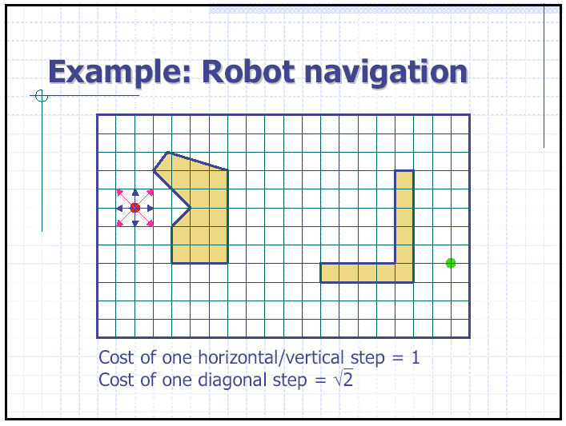

The navigation problem is as follows: The robot is a point moving on a planar regular grid. We assume that the robot moves between grid nodes, so that the state space is the set of grid nodes. There are static obstacles and the robot is only allowed to be at grid nodes not contained in obstacles. The successors of any grid node (a state) are all the neighbors of this node (up to 8) that are not contained in obstacles. The cost of a horizontal/vertical step is 1. The cost of a diagonal step is sqrt(2). The robot must go from a start grid node to a goal grid node. Each grid node is defined by its two coordinates (x,y) in a coordinate system.

Give 4 heuristic functions h1, h2, h3, and h4 that are, each, both admissible and consistent. Rank them from the least to the most informed. Explain briefly your answers.

The following are the heuristics ranked from least to most informed (h4 is most informed).
Let (xg,yg) be the goal’s coordinates.
h₁ = 0 Trivial admissible and consistent heuristic
h₂ = |x_{g}-x|
h₃ = |y_{g}-y|
h₄ = sqrt[(x_{g}-x)²+(y_{g}-y)²]

h4 is the Euclidean distance to the goal, i.e., the length of the straight path to the goal. Hence, it can be no longer than the length of the optimal path in the grid with or without obstacles. So h4 is optimistic, hence admissible.

(x_{g}-x)²+(y_{g}-y)² >= (x_{g}-x)²
(x_{g}-x)²+(y_{g}-y)² >= (y_{g}-y)²
so h2 and h3 are both <= h4, and are both admissible.

Let us prove consistency for h2 (and by symmetry, h3). Consider a node n = (x,y) and a successor n’=(x’,y’). We have c(n,n’) = 1 or sqrt(2). In addition |x-x’| = 0 or 1, so it’s always <= c(n,n’). We have (classical triangular inequality):
|x-x’|+|x’-xg| >= |x-xg|
So:
|x-xg| <= c(n,n’) + |x’-xg|
Therefore, h2 is consistent.

The prove h4 is consistent, note that (using the same n and n’ as above)
sqrt((x_{g}-x)²+(y_{g}-y)²)
<= sqrt((x_{g}-x’)²+(y_{g}-y’)²)+ sqrt((x-x’)²+(y-y’)²)
<= sqrt((x_{g}-x’)²+(y_{g}-y’)²)+c(n,n’)

because c(n,n’)= sqrt((x-x’)²+(y-y’)²)

III. (5 points) Prove each of the following statement:
- Breadth-first search is a special case of uniform-cost search.
- Breadth-first search is a special case of best-first search.
- Depth-first search is a special case of best-first search.
- Uniform-cost search is a special case of A* search.
Briefly explain your answers. In particular, for each of the two statements 2 and 3, what is the evaluation function used by the equivalent best-first search? For statement 4, what is the heuristic function used by the equivalent A* search?

1.When all step costs are equal, the cost g(n) of a path from the start node to a node n is proportional to depth(n). Then uniform-cost search reproduces BFS with the modified search algorithm (a node is tested to be the goal when it is removed from the fringe).

2.BFS is best-first with f(n)=depth(n)
3. DFS is best-first with f(n)=-depth(n) or f(n) = 1/depth(n)
4.UCS is A* with h(n)=0

IV. (5 points) Invent a heuristic function for the 8-puzzle that sometimes overestimates the cost to reach the goal, and show how it can lead to a suboptimal solution on a particular problem.

Consider a heuristic h(s) that returns 0 if the state is a goal and otherwise returns a random number between 1 and N where N is large enough to ensure that sometimes it overestimates. For the example below, let N=20 and suppose that we start with the following state
123
475
68
The following A* trace shows how a sub-optimal solution would be found. Note that when the goal is found, all unexpanded nodes have estimated cost greater than the actual cost of the goal that is found.
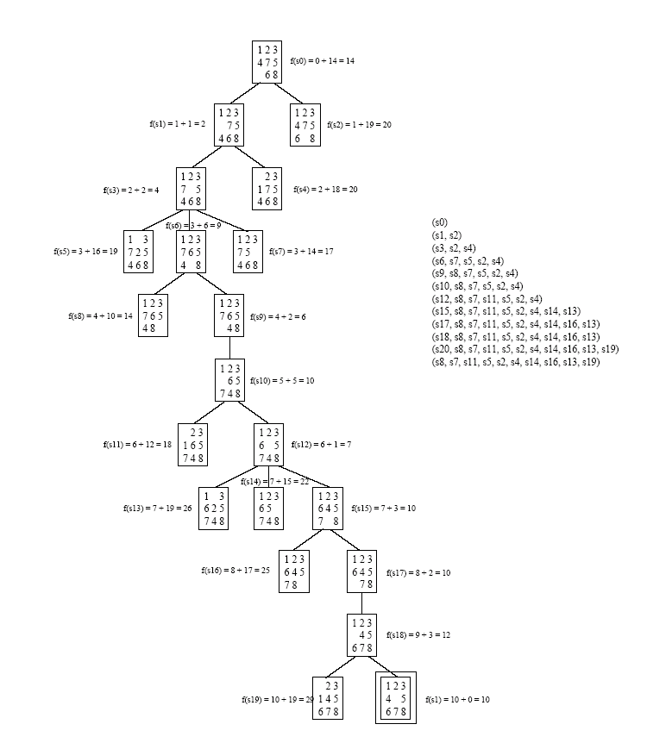
V. (5 points) Prove that if a heuristic function h never overestimates the cost to reach the goal by more than a positive constant c, that is:
for every node N: 0 ≤ h(N) ≤ h*(N)+c,
where h*(N) is the cost of the minimum-cost path from N to a goal node, then A* search using h returns a solution whose cost does not exceed that of the minimum-cost path by more than c.

Now, suppose h(n) <= h*(n)+c as given and let G2 be a goal that is sub-optimal by more than c, i.e. f(G2)=g(G2) > C* +c. Now consider any node n on a path to an optimal goal. We have
f(n)=g(n)+h(n) <= g(n)+h*(n)+c <= C*+c <= f(G2)
so G2 will never be expanded before an optimal node is expanded
because f(n)<f(G2)

VI. (5 points) Perform A* on the search tree shown below with edge costs shown near each edge (in red) and the goal node shown shaded. Label the nodes (inside the circles depicting the nodes) in the order that they are expanded by the algorithm (1 for the start node, 2 for the second node, etc.). Also fill in the f-value (the value of the evaluation function f = g + h) of each node that is put into the priority queue (fringe), and leave the f-values for all other nodes blank.
1
2
5
6
7
3
4
h = 2
f = 5
h = 2
f = 8
h = 1
f =
h = 3
f = 8
h = 2
f = 9
h = 0
f = 6
h = 1
f = 5
h = 2
f = 4
h = 5
f = 8
h = 2
f = 3
h = 2
f = 9
h = 1
f = 3
h = 5
f =11
h = 5
f =
h = 2
f = 7
h = 2
f = 9
h = 1
f = 6
h = 2
f = 6
3
3
1
1
2
3
1
2
1
1
3
1
3
6
1
3
4
3
S
G

After the node labeled 6 is expanded, there is a tie, since two nodes have f=6, one being the goal. Either one is removed from the fringe. If the goal node is removed, we are done, If the non-goal node is removed from the fringe first, has no successor, and the goal node ies removed next.

