Comprehensive Exam in Human-Computer Interaction

Scott Klemmer, 14 November 2006



1 | / 20
2 | / 16
3 | / 15
4 | / 16
5 | / 15
6 | / 18
Total | / 100

This is an open book, open note exam. You may use a laptop computer and the internet to reference course readings and lecture notes only; all other use is prohibited.

MAGIC NUMBER:
1. Pointing and Fitts’s Law [20 Points]

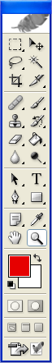
(a) [12 Points]

The window shown to the left is the movable tool palette for selecting drawing tools in Adobe Photoshop. The user selects a tool by clicking on one of the icons in the palette. Assume the user is running Photoshop on a standard desktop machine using a mouse.

The Fitts’s formula for Movement Time (MT), given in Hinckley’s paper, is

MT = a + b log₂ (A/W + 1)

For each of the variables (a, b, A, and W), describe what it measures, and suggest how to redesign tool selection in Photoshop to decrease MT based on a change to that variable.

(b) [8 Points]

The MacOS has a single menu bar at the top of the screen, which changes contents to suit whatever application is currently active. Windows puts a menu bar near the top of each active window, below the windows’ title bars.

i. From a cognitive perspective, what principles argue for doing it the Windows way?

ii. From the perspective of Fitts’s Law, what is the advantage of the Macintosh way?
2. User Testing [16 Points]
To make use of your newly acquired expertise in HCI, you volunteered as a peer reviewer for an academic conference, and you were invited to review a paper submission entitled “Improving Data Entry with the GOOBER System.” Read the following excerpt from the paper’s “Evaluation” section.
To evaluate my system, I invited undergraduate CS students enrolled in my course to participate in an experiment for extra credit. I explained to them that they would be comparing an old system for data entry (Microsoft Excel) to a new data entry system that I had been building for three years. Five participants were asked to enter one page of data, first using Microsoft Excel, and then using my GOOBER system. I then asked participants to rate both systems on an integer scale from 1 (bad) to 4 (phenomenally awesome). Excel received an average rating of 3, while GOOBER received an average rating of 3.5. Several subjects commented that GOOBER was “easy to use” and “intuitive.”

Point out four problems with the experimental methodology, and suggest a way to fix each problem. [4 points each]
3. Heuristic Evaluation [15 Points]

(a) While performing a heuristic evaluation of a file transfer program you see the following dialog. Describe one problem with the dialog by identifying a heuristic, describing the problem (in one sentence) and describing a potential fix in another sentence. [6 points]
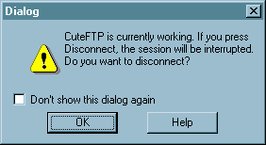
Heuristic:

Problem:

Fix:
(b) One of Nielson's Heuristics is “Recognition Rather than Recall.” Why is this heuristic sometimes more difficult to satisfy in speech user interfaces than in graphical user interfaces? What is an example of a technique you can use to address this issue? What is a major trade-offs your solution may introduce? [9 points]

4. Design Patterns [16 Points]
(a) Draw an example sketch of the use of Breadcrumbs, and describe briefly (in <3 sentences) what this design pattern is used for. [5 Points]

(b) Describe the basic principle of the Process Funnel design pattern and how it is used in websites. [5 Points]

(c) The Model-View-Controller pattern is often used in building web applications.
- Complete the Model-View-Controller diagram by writing text in the empty circles. [2 Points]
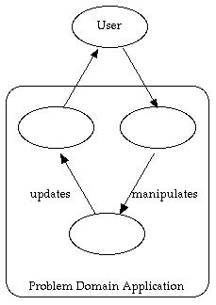

- Describe the primary advantages of the MVC pattern, in three sentences or fewer. [4 Points]

5. Task Analysis [15 points]
Microsoft has just hired you as an interface designer. Your first assignment is to design a newspaper layout tool.
This software is targeted towards journalism classes in several junior high schools in low-income neighborhoods. Students in these courses are less familiar with computers, as most do not have them at home. They are more familiar with video arcade games and Xbox-style home entertainment systems. Thus, they currently do not use many software tools. Instead, they write stories with typewriters and layout articles using scissors and glue.
The teaching staff is happy with the typewriter/scissors approach. However, they are willing to give the new software a chance, given that it will support the current tasks and provide more flexibility in story editing and newspaper layout.
Ask and answer ﬁve standard task analysis questions about the newspaper layout tool. For example: who are the users? Your answers to these questions should come directly from the above assignment and logical inferences about the assignment. Answers should be specific and detailed.

6. Experimental Design [18 Points]

(a) Circle the one answer that best completes the sentence [4 points]
A between-groups experimental design:
A. means that each participant uses all of the systems being compared.
B. specifies what occurs between the time you test two different participants.
C. means that each participant uses only one of the systems being compared.
D. reduces the variability in the results.
E. is best for testing low-level interaction techniques.

(b) What type of users, performance, and tasks are goms analyses generally limited to? [6 points]

(c) What are four common dependent variables in an HCI experiment? [8 points]

